1 – google excel issue
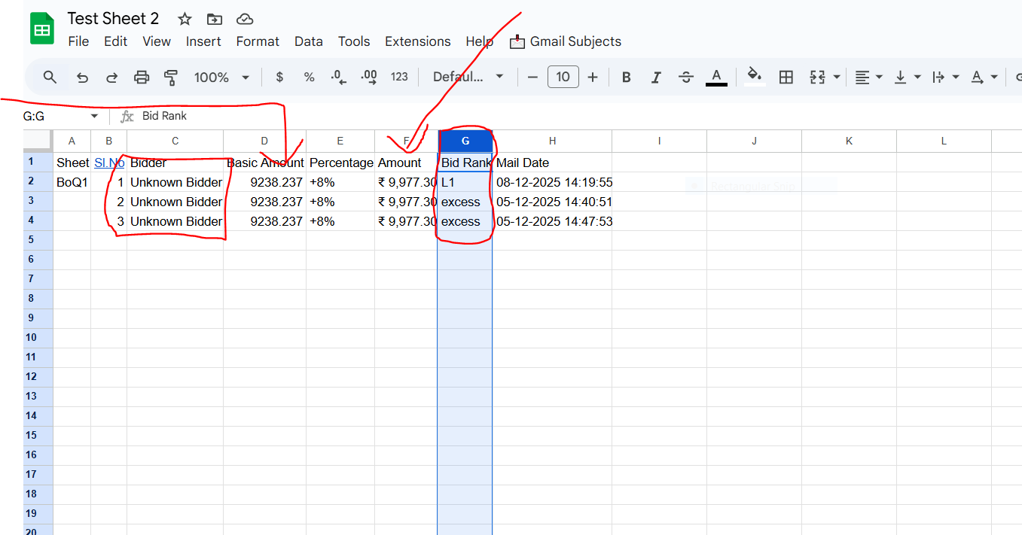

- Bidder name should be show as per BOQ sheet
- Basic amount should be correct as BOQ Sheet
- Percentile amount should be show as per percentage of basic amount
- Rank should be L1 L2 L3 … so on.

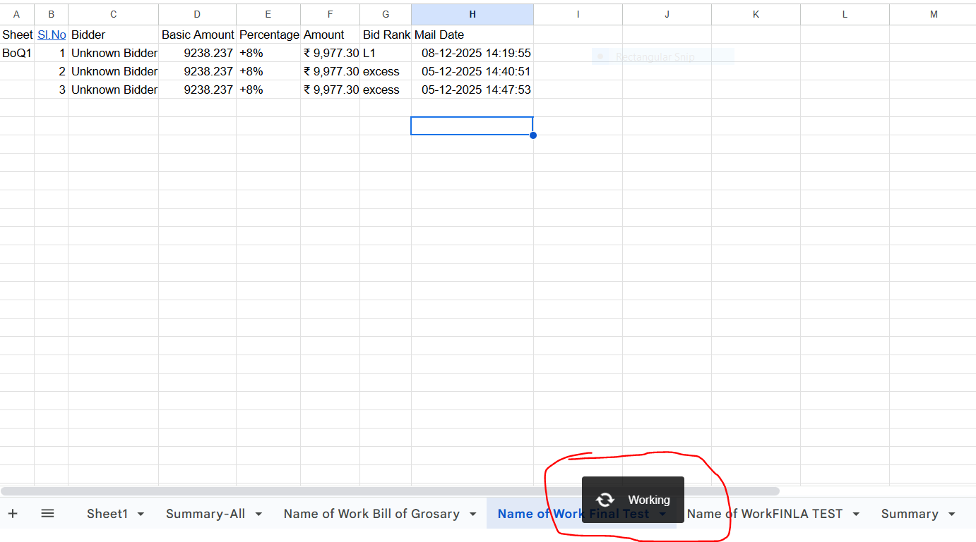
- Working popup should not be showing continuously.

